Table of Contents

Page

**1. Project Proposals 1**

(I) Project Goal 1

(II) Project Objectives 1

(iii) Project Scope 1

1.Context 1

2. Target Language Platform 1

a) Microsoft SQL Server 1

b) ASP.NET 2

3. Stakeholders of the product 2

4. What is Web Application 3

**2. Analysis Documentation 4**

a) Problem with existing System 4

b) Proposed System

**3. Hardware Requirement 5**

**4. Software Requirement 5**

**5. Design Documentation 6**

1. Data flow diagram 6

a)Context Diagram 6

b) Level 1 6

2) ER Diagram 7

**6. Design Documentation 8**

a) Creating ASP.NET Core Web Application in Visual Studio 2017 8

**7. Summary 14**

**8. References**  **15**

Introduction

# 1. Project Proposals

## **(I) Project Goal**

We will have a Web Application named ‘Sports pro’ which is a database driven website.

## **(II) Project Objectives**

The project objective is to

* Design a web application that can handle and manage the activities the CRUD(Create, Read, Update, and Delete).
* Develop a system that can Add players detail.
* Develop a database which contains Player team Data who is coming for tails.
* Create user friendly interface .
* Reducing most of the paper work by developing database.
* Reducing human error by edit and delete feature..

## **(iii) Project Scope**

### **1.Context**

We will create a Web Application named ‘Sports pro’ which is derived by database model based on entity framework.

We will give CRUD(Create, Read, Update, and Delete) .

In the project there should be database that is added to the project by using controllers.

### **2. Target Language Platform**

#### **a) Microsoft SQL Server**

Microsoft SQL Server in which we can create database and tables to store the information. As a database server, it is a software product with the primary function of storing and retrieving data as requested by other software applications—which may run either on the same computer or on another computer across a network (including the Internet.

#### **b) MVC ASP.NET**

#### Mvc asp.net is the core lframework in which full project is going to be developed main feature and advantage of using mvc is they provide predefined web template which a person needs to change or modify by there own prefrences and it is more likely highly used framework for web apps.

**3. What is Web Application**

A web application is a computer program that utilizes web browsers and web technology to perform tasks over the Internet.

**OVERVIEW**

Millions of businesses use the Internet as a cost-effective communications channel. It lets them exchange information with their target market and make fast, secure transactions. However, effective engagement is only possible when the business is able to capture and store all the necessary data, and have a means of processing this information and presenting the results to the user.  
  
Web applications use a combination of server-side scripts (PHP and ASP) to handle the storage and retrieval of the information, and client-side scripts (JavaScript and HTML) to present information to users. This allows users to interact with the company using online forms, content management systems, shopping carts and more. In addition, the applications allow employees to create documents, share information, collaborate on projects, and work on common documents regardless of location or device.

**HOW A WEB APPLICATION WORKS**

Web applications are usually coded in browser-supported language such as JavaScript and HTML as these languages rely on the browser to render the program executable. Some of the applications are dynamic, requiring server-side processing. Others are completely static with no processing required at the server.  
  
The web application requires a web server to manage requests from the client, an application server to perform the tasks requested, and, sometimes, a database to store the information. Application server technology ranges from ASP.NET, ASP and ColdFusion, to PHP and JSP.

**Here’s what a typical web application flow looks like**:  
  
User triggers a request to the web server over the Internet, either through a web browser or the application’s user interface  
Web server forwards this request to the appropriate web application server  
Web application server performs the requested task – such as querying the database or processing the data – then generates the results of the requested data  
Web application server sends results to the web server with the requested information or processed data  
Web server responds back to the client with the requested information that then appears on the user’s display

**EXAMPLE OF A WEB APPLICATION**

Web applications include online forms, shopping carts, word processors, spreadsheets, video and photo editing, file conversion, file scanning, and email programs such as Gmail, Yahoo and AOL. Popular applications include Google Apps and Microsoft 365.  
  
Google Apps for Work has Gmail, Google Docs, Google Sheets, Google Slides, online storage and more. Other functionalities include online sharing of documents and calendars. This lets all team members access the same version of a document simultaneously.

# 2. Analysis Documentation

Analysis of the project is getting demand to built a web app that manager of the tournament can save the data of players he should be able to insert there details from all over the world that are coming tokyo for world rugby league

## a) Problem with existing System

There is also old system that is basically manual. To resolve this problem need to develop the drop down menu which consumes countries and there linked team name to ease the sysstem and save the time by not manual typing.

## b) Proposed System

The proposed system is to:-

* Design a web application that can handle and manage the activities the CRUD(Create, Read, Update, and Delete) for the administrator to easily handle the tournament activities for registration in an efficient and reliable way.
* Develop a system that can replace a manual system.
* Develop a database which contains details of countries and there representative teams in a drop down list .
* Create an attractive, easy to understand, and user-friendly interface.
* Reducing time of manual work.
* Reducing human error and redundancy in the database.
* Fast access to the database

3. Hardware Configuration

Processor: Intel Core i3 3.24GHz  
RAM: 2 GB

4. Software Configuration

Operating System: Windows 7, Window 10   
Language: ASP.NET

Database: Microsoft SQL Server

Application: Visual Studio 2017

**5. Design Documentation**

**Data Flow diagram**

**a) Context Diagram**

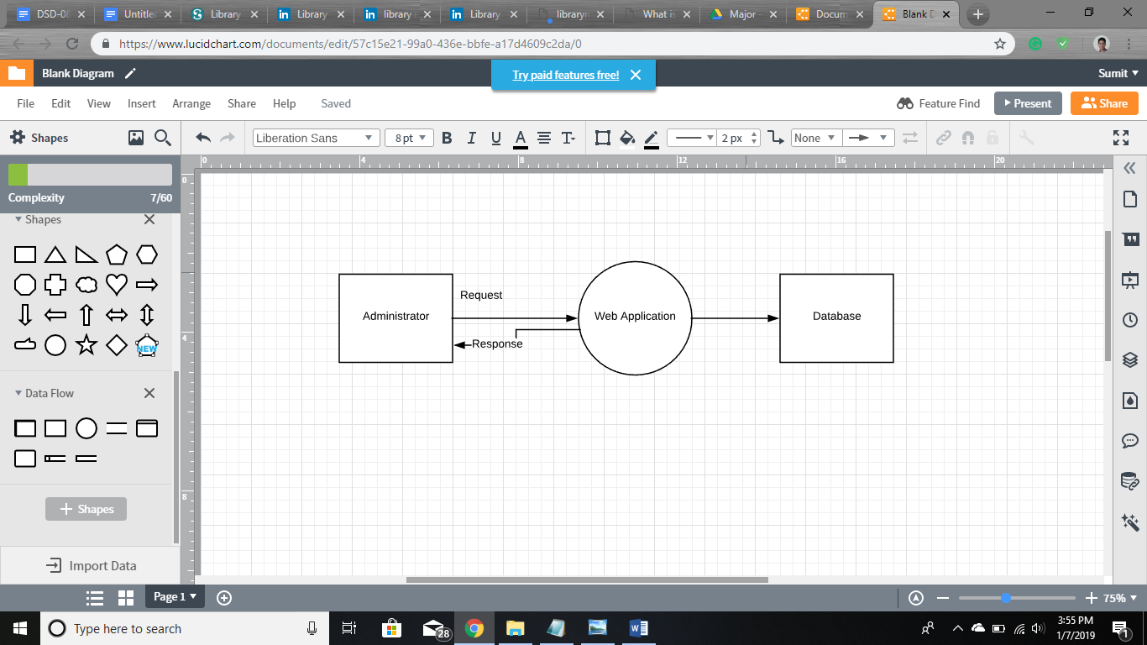

c) Entity- Relationship Diagram

Players_id

position

Last_name

country

provience

city

Team name

NHL

First_name

6. Design Documentation

## 

## **Creating ASP.NET Core Web Application in Visual Studio 2017**

Firstly, Launch Microsoft Visual Studio 2017. Create a New Project, when prompted choose ASP.NET Core Web Application.

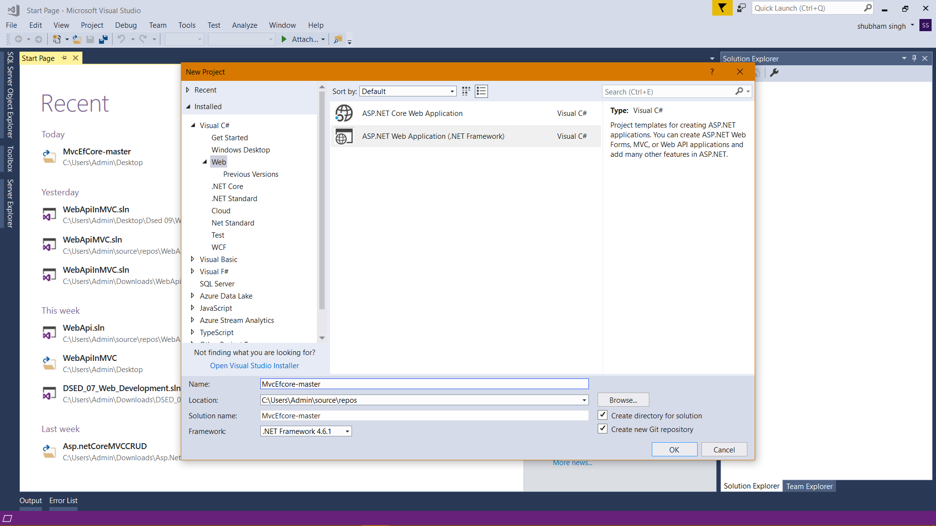

When prompted choose ASP.NET Core 2.0, the Web Application MVC template and change Authentication to Individual User Accounts for Login and Register, in the lab computers do not “Configure for HTTPS” for now, and then click OK.

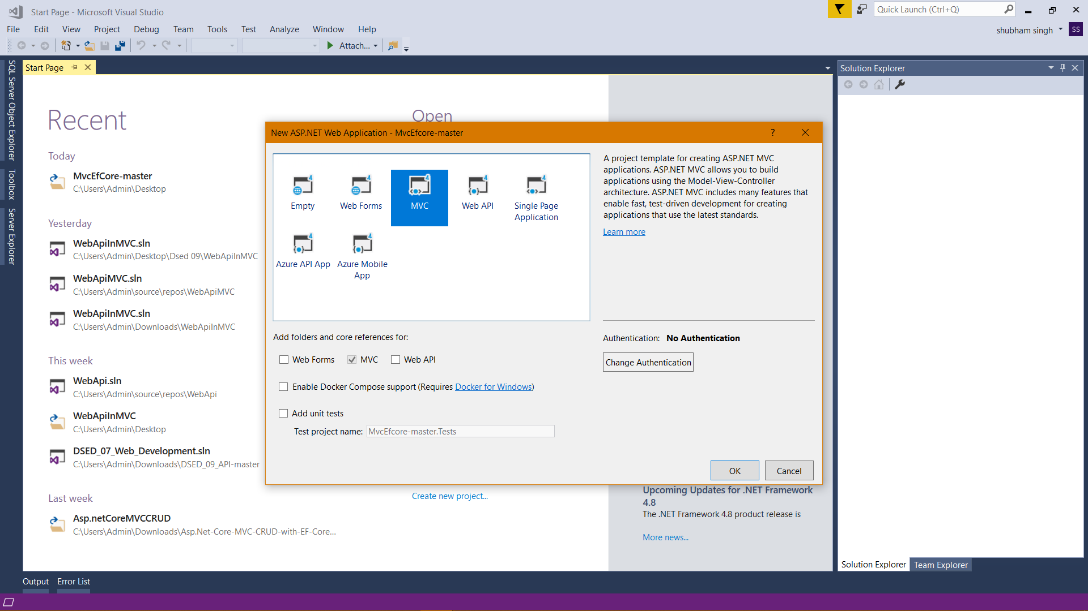

After Creating ASP.Net Web Project, Below Solution Explorer will create : -

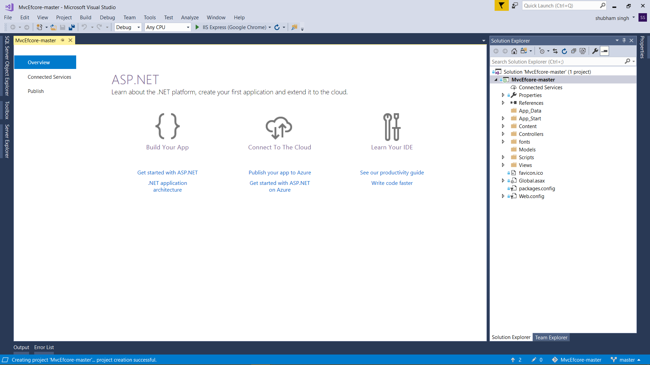

Build and Run this default website on IIS Express:-

#### **Adding Scaffolding to Create CRUD :-**

Asp.net will provide a template to generate controllers and views based on the database.

Right-click the Controllers folder in Solution Explorer, select **Add | Controller…**

Add an **MVC Controller with views using Entity Framework**

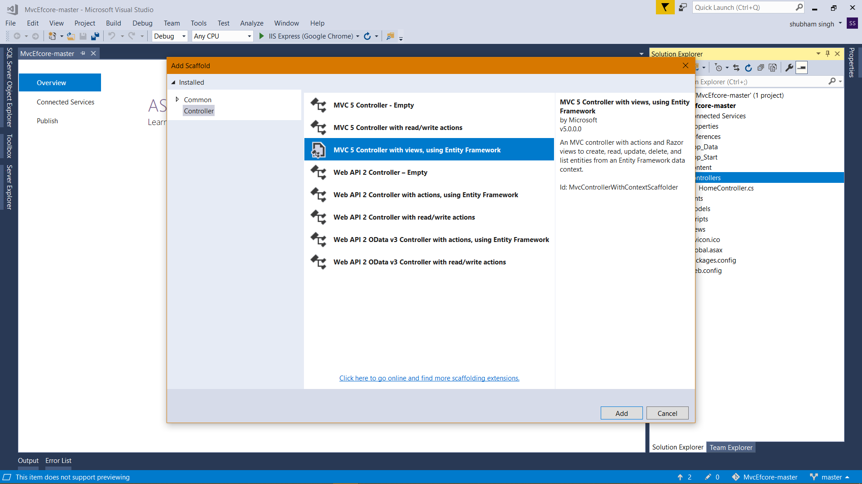

### 

### **Creating two controllers as players and team this will lead us to modify the details of the database**

1. DATABASE is already created (Created Table Players
2. Filled all Details in tables.
3. Details of player and team.

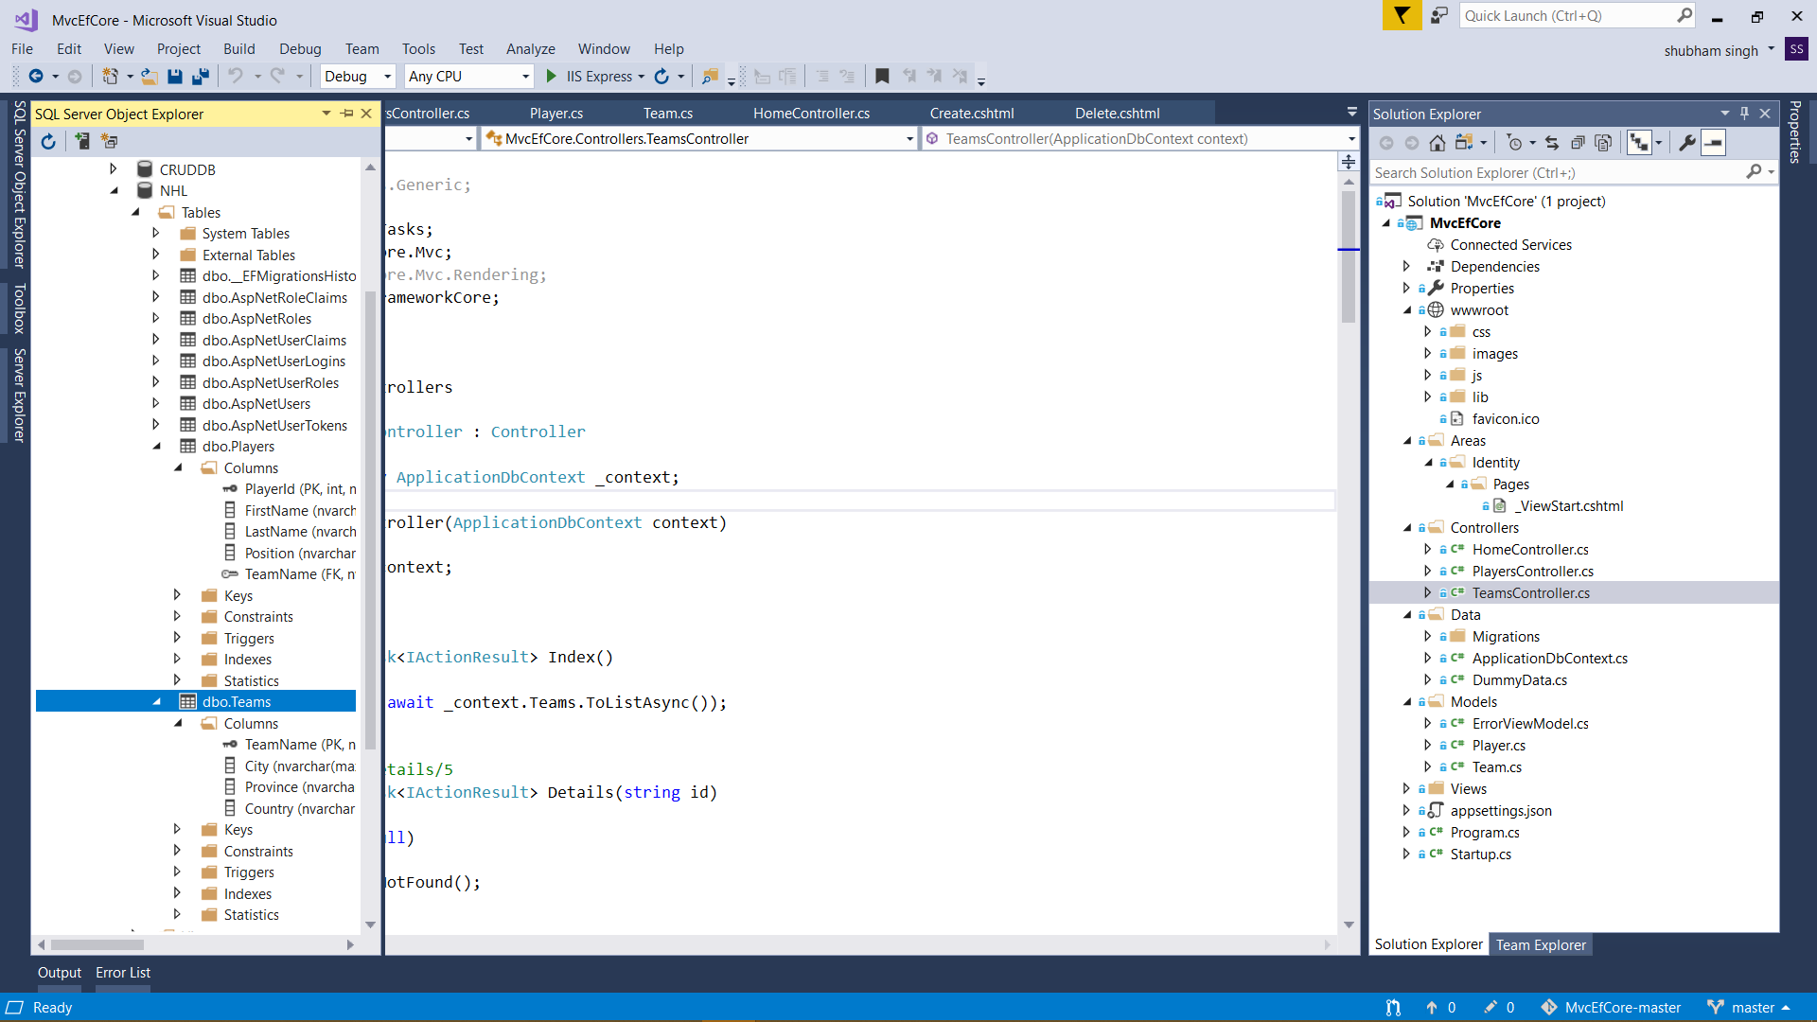

After creating controlles next step is to design the pages with css and adding some random pictures to the project that will enhance the overall presentation of the project :

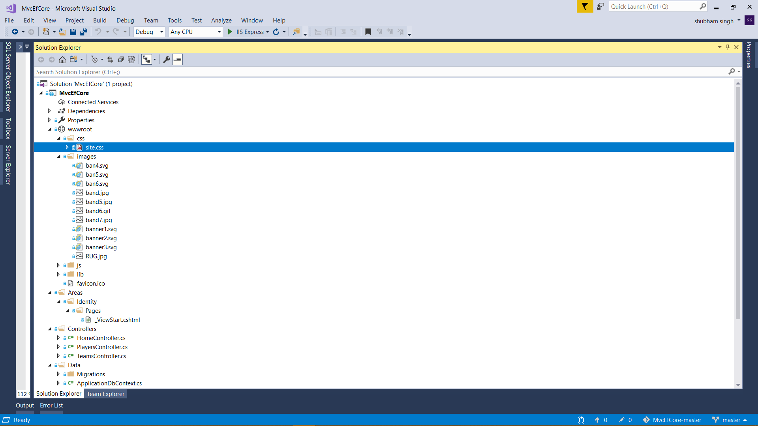

**After building and Running the Projects following viewsof the project will Show with all the functionality:**

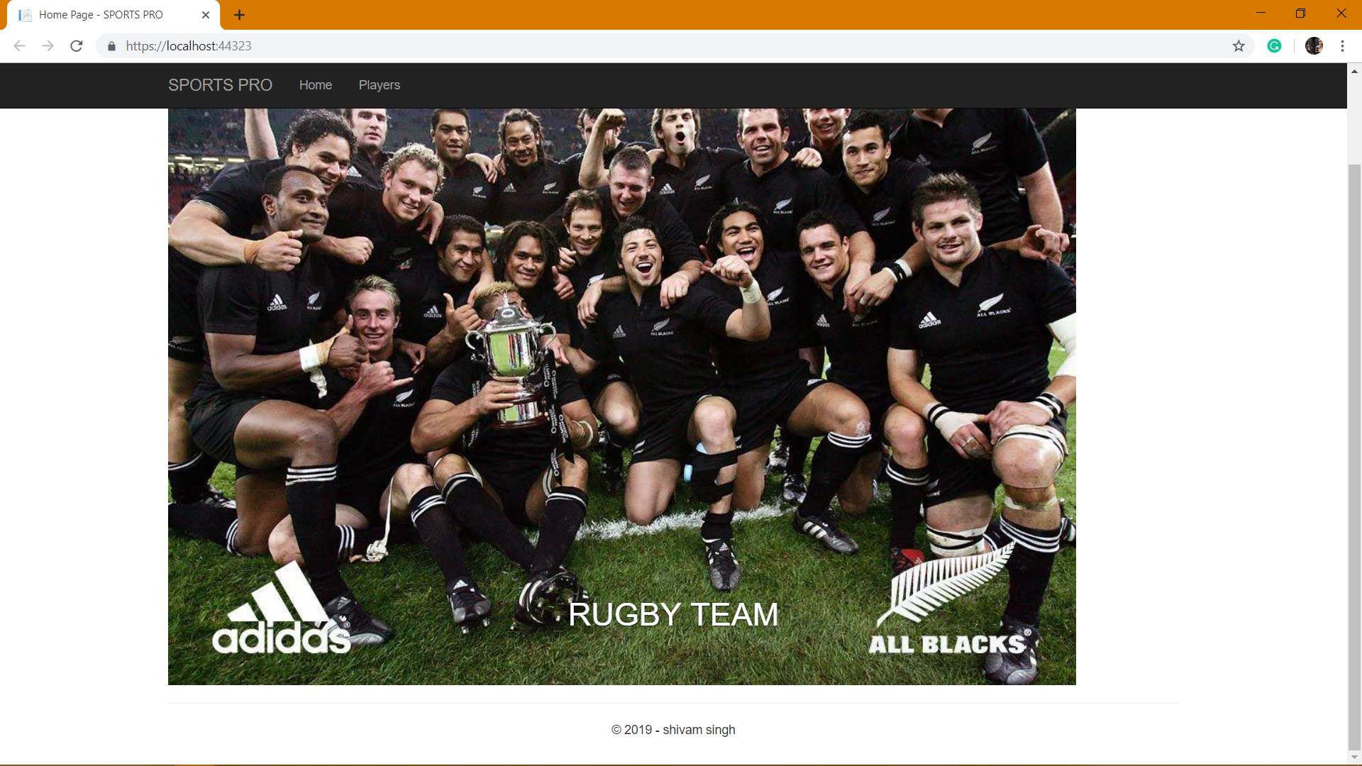

**This pane will come up after clicking on players on the navbar:**

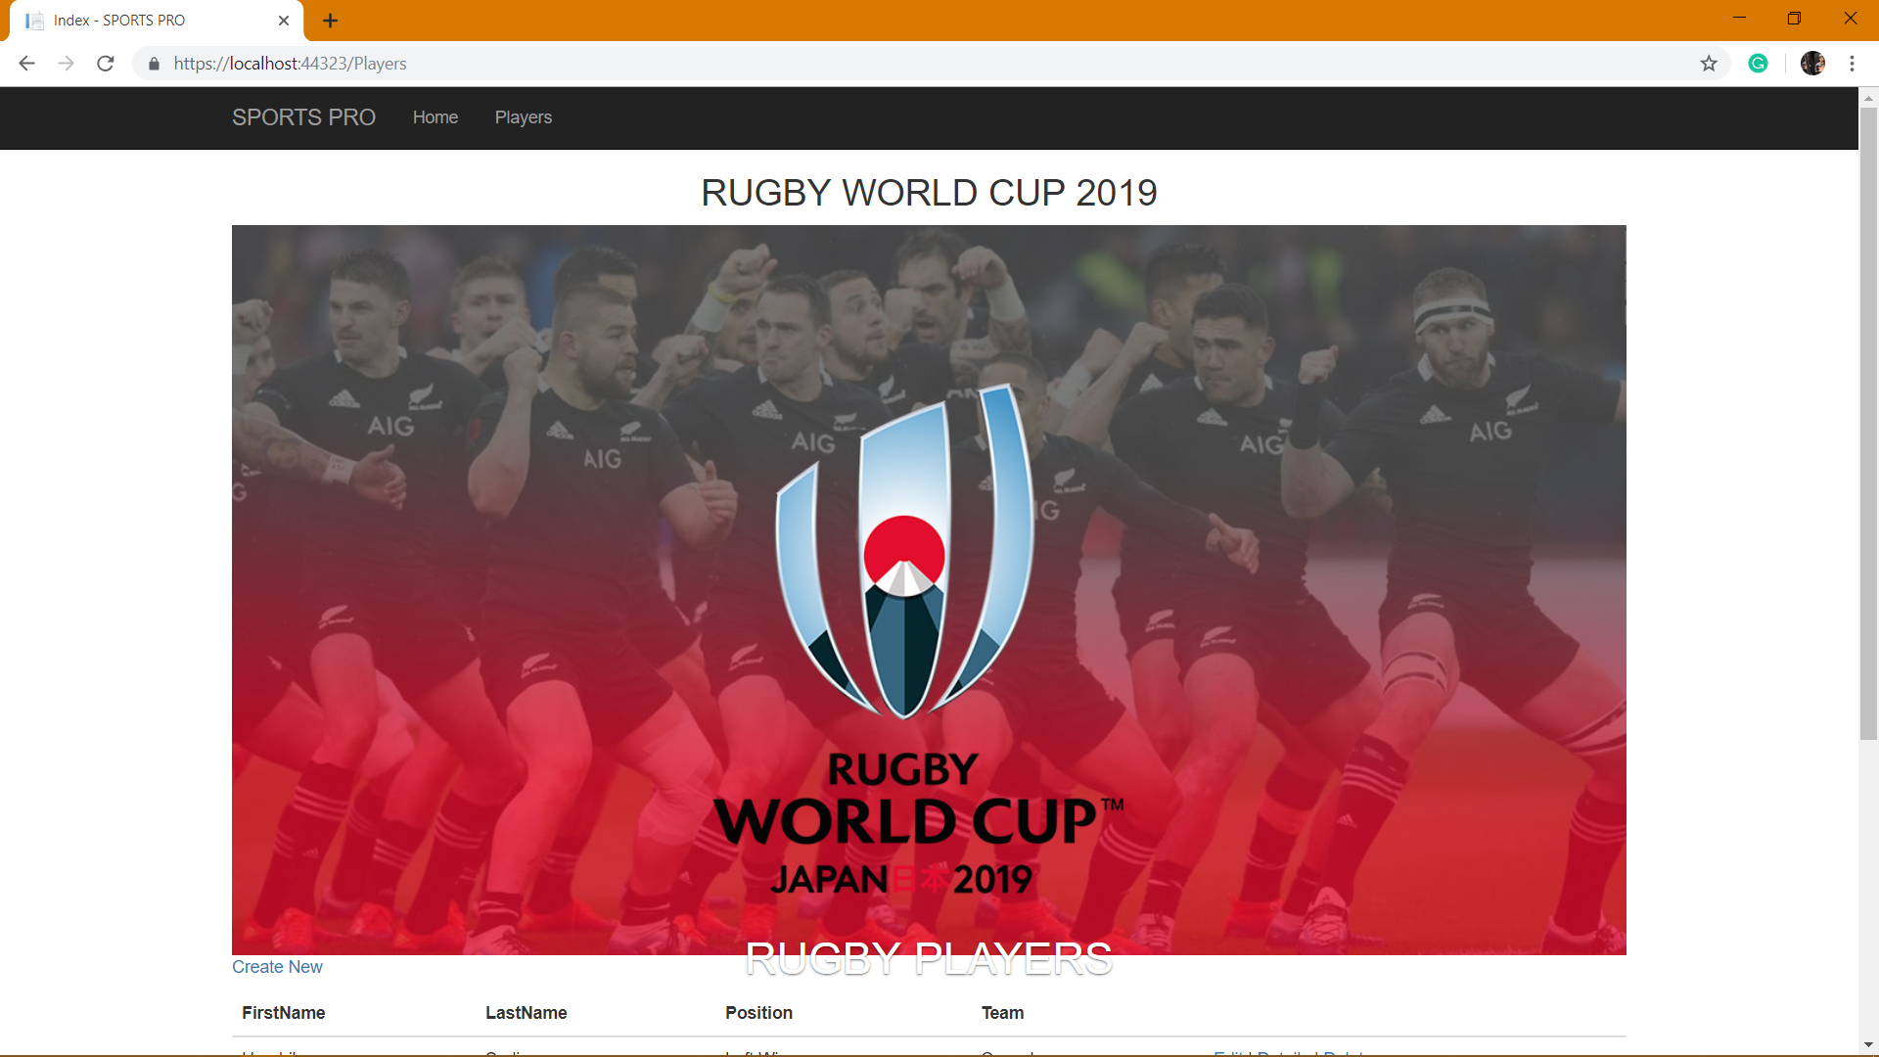

**This is the show panel of all the details of the player here indidual can edit, get more details and can delete a player**

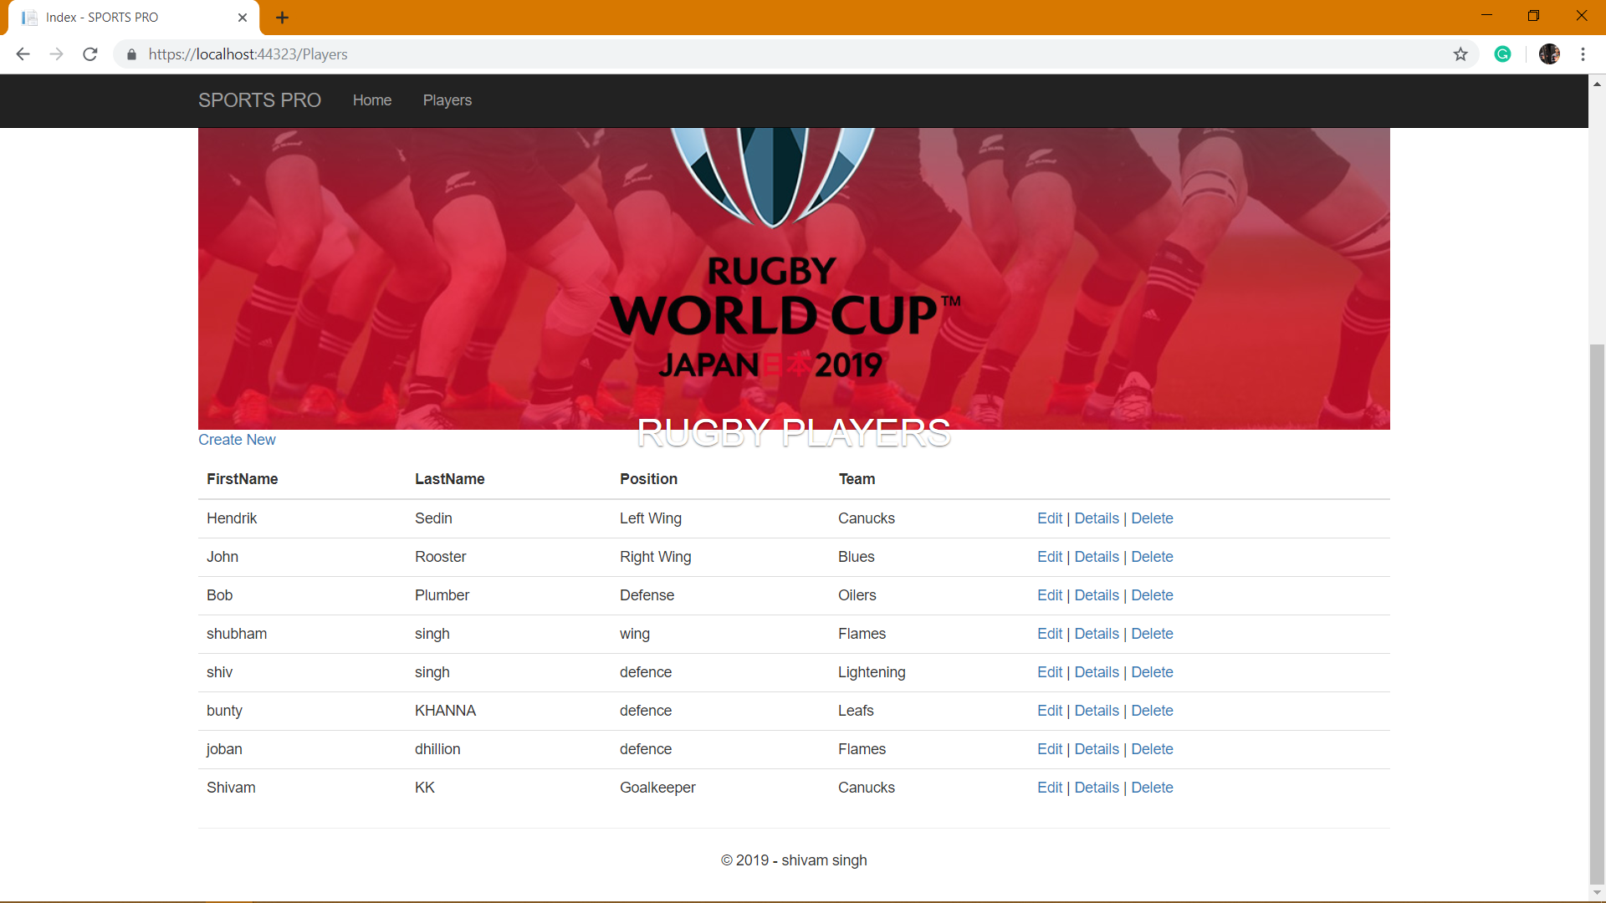

To insert a new player person need to to click on create new after that this menu will pop up :

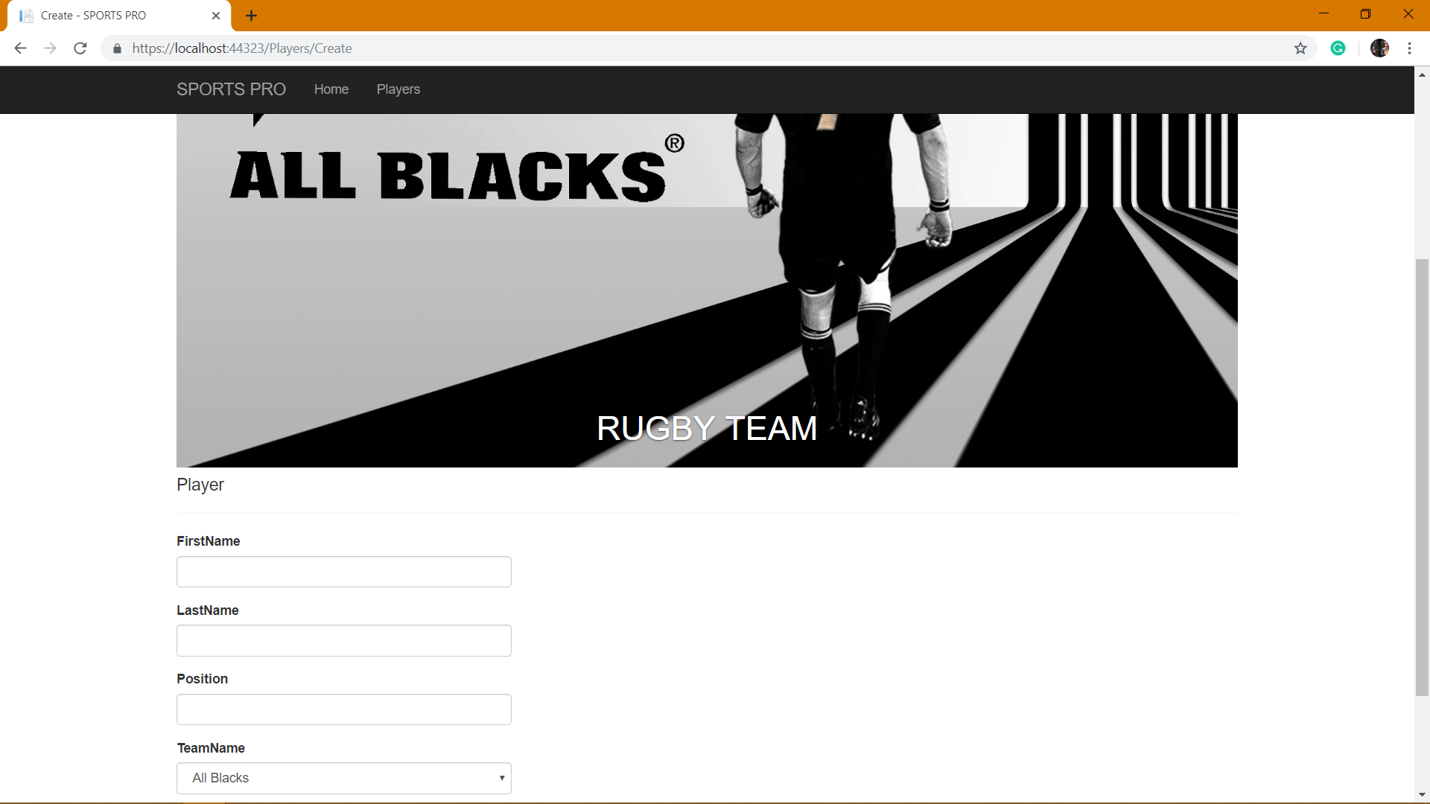

**In case a players name is misspled or any modification needs to be changed user need to click on edit this will generate a new window for edit :**

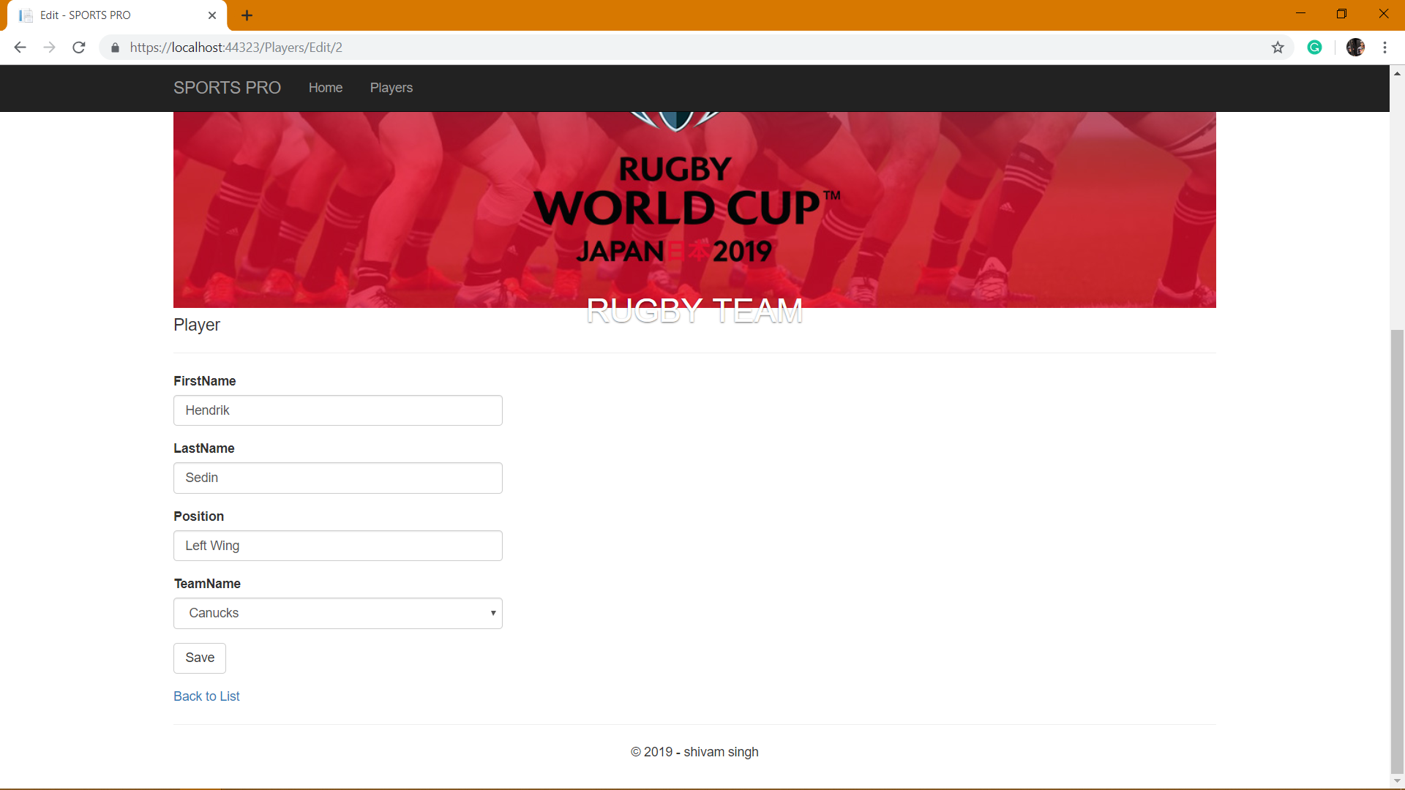

**The main functionallity of detail is it show players detail is singular seprate pane that provide accurate detail without getting confused:**

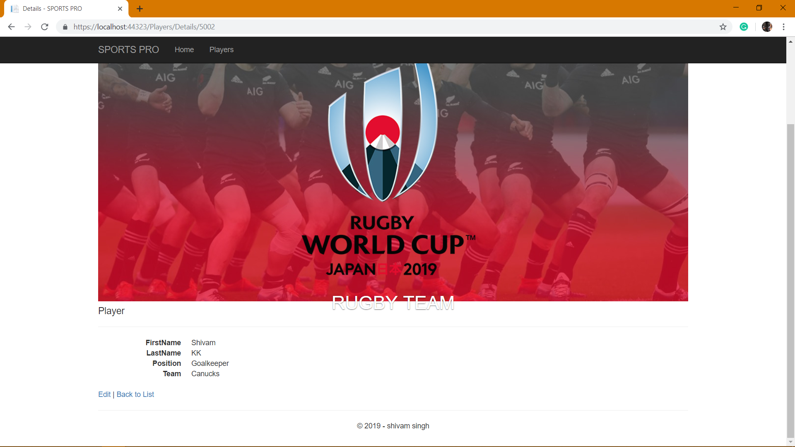

**To delete a player simply user need to click delete on a selected player once delete button is clicked a new window will open asking**

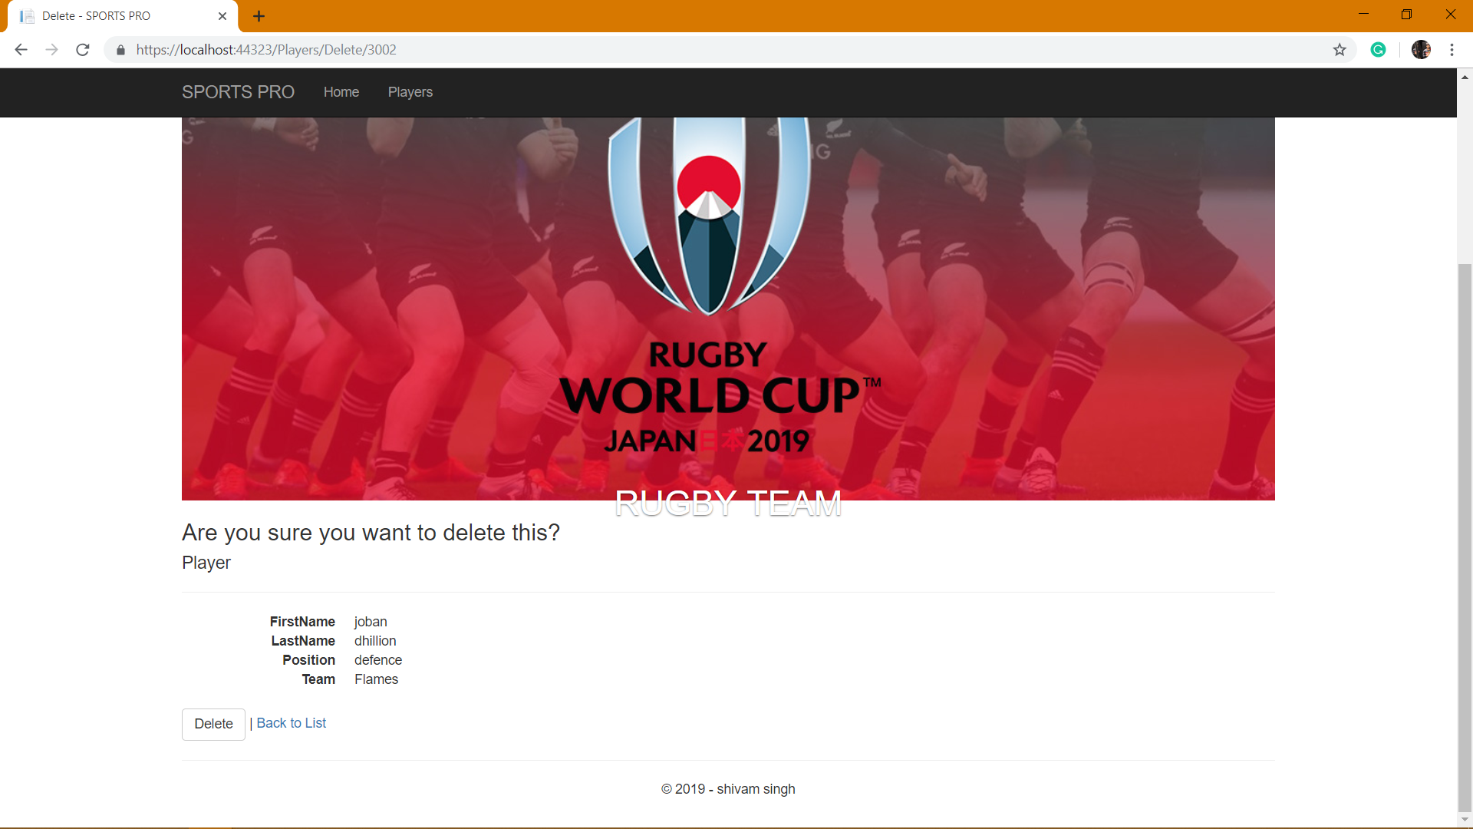

7. Summary:

This project is Created in ASP.net Core for web application with drop down list of countries leading to team which will ease user to put details.it is created on MVC Framework with Database back End using Entity Framework, With LINQ. In Web Application, Admin Can Handles All Details About Database. Admin Can Edit, View, Add and Delete. Database Backend for this project is created using MSSQL-Server.

**8. References**

1.https://www.maxcdn.com/one/visual-glossary/web-application/  
2.https://www.tutorialspoint.com/asp.net_core/asp.net_core_overview.htm  
3.https://en.wikipedia.org/wiki/Microsoft_SQL_Server  
4.https://en.wikipedia.org/wiki/C_Sharp_(programming_language)